**Hadoop Configuration & Installation - Single Node**

**(standalone mode)**

**System requirements**

* A Linux version installed.
* Java Installed.
* I would recommend you have 8GB RAM. Allocate your Linux partition disk 50+ GB of storage as you will be storing huge data sets for practice.

**Step 1: Add a Hadoop user**

* We will use a separate Hadoop user account for the execution of Hadoop. Although it is not mandatory, it is recommended, as it allows the Hadoop installation to be separated from the other software applications and user accounts running on the same machine (security, permissions, backups…)
* Login as root: sudo su

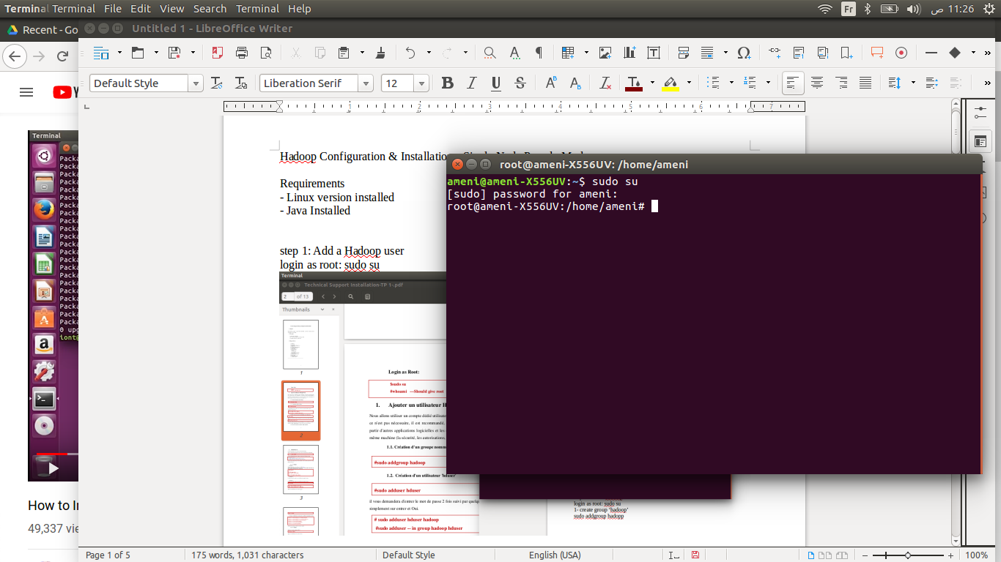

1- Create group ‘myhadoop’

sudo addgroup myhadoop

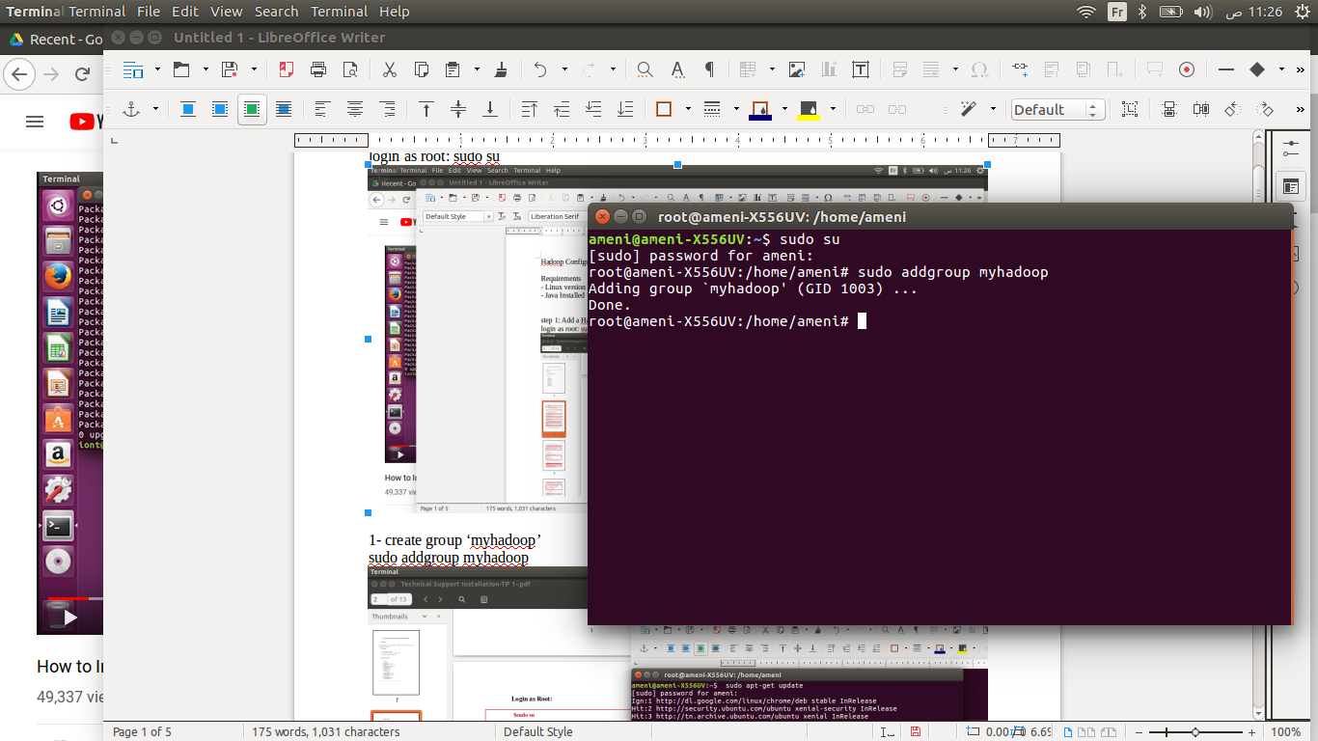

2-Create user ‘userhd’

sudo adduser userhd

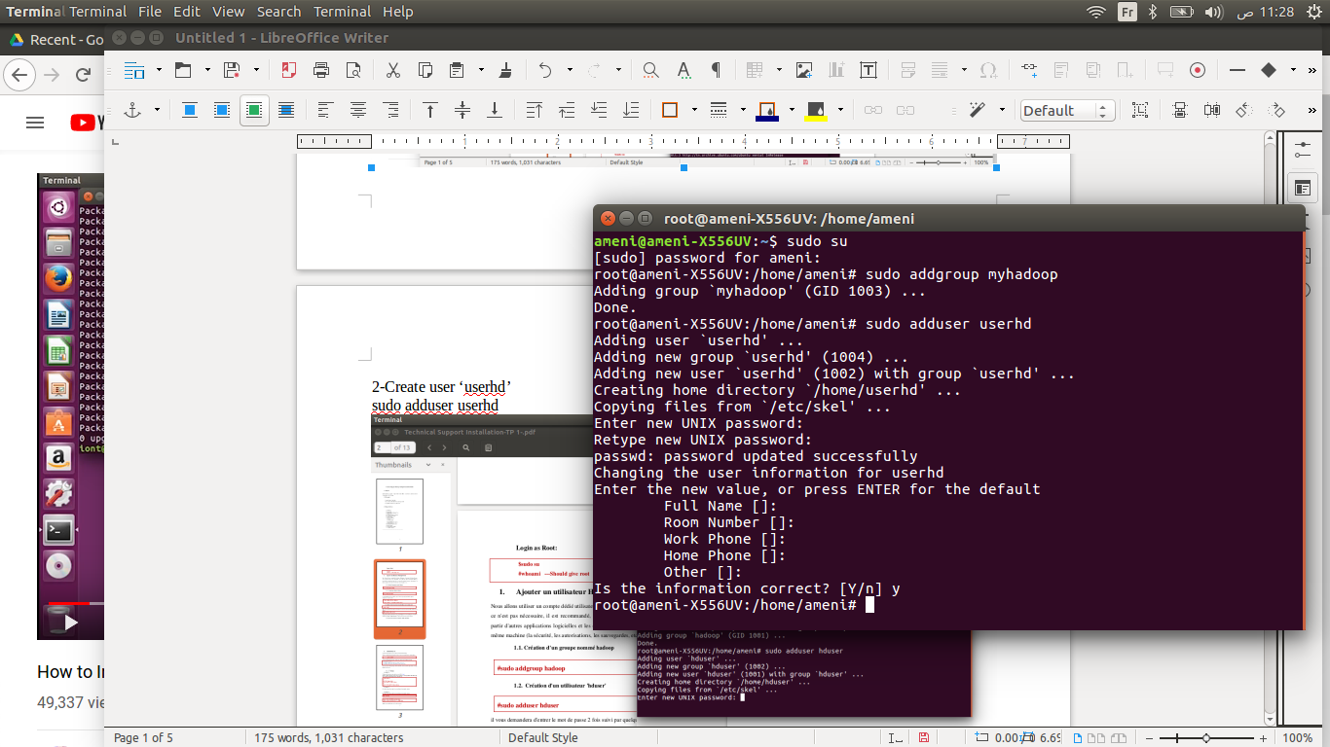

* It will request you to enter the password twice followed by a few details, just press **Enter** and **Yes**. (in my case password : userhd)

3- Add ‘userhd’ in group ‘myhadoop’

sudo adduser userhd myhadoop

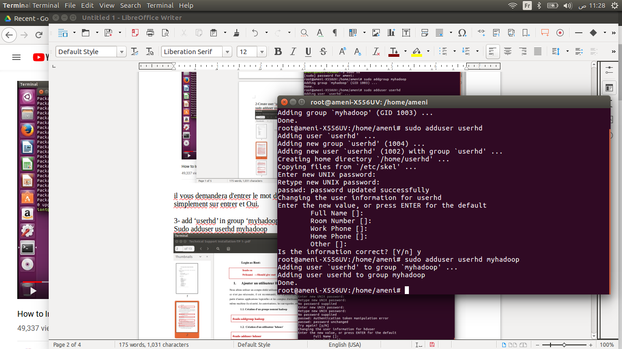

4- Add the 'userhd' to sudoers list so that userhd can do admin tasks

sudo visudo

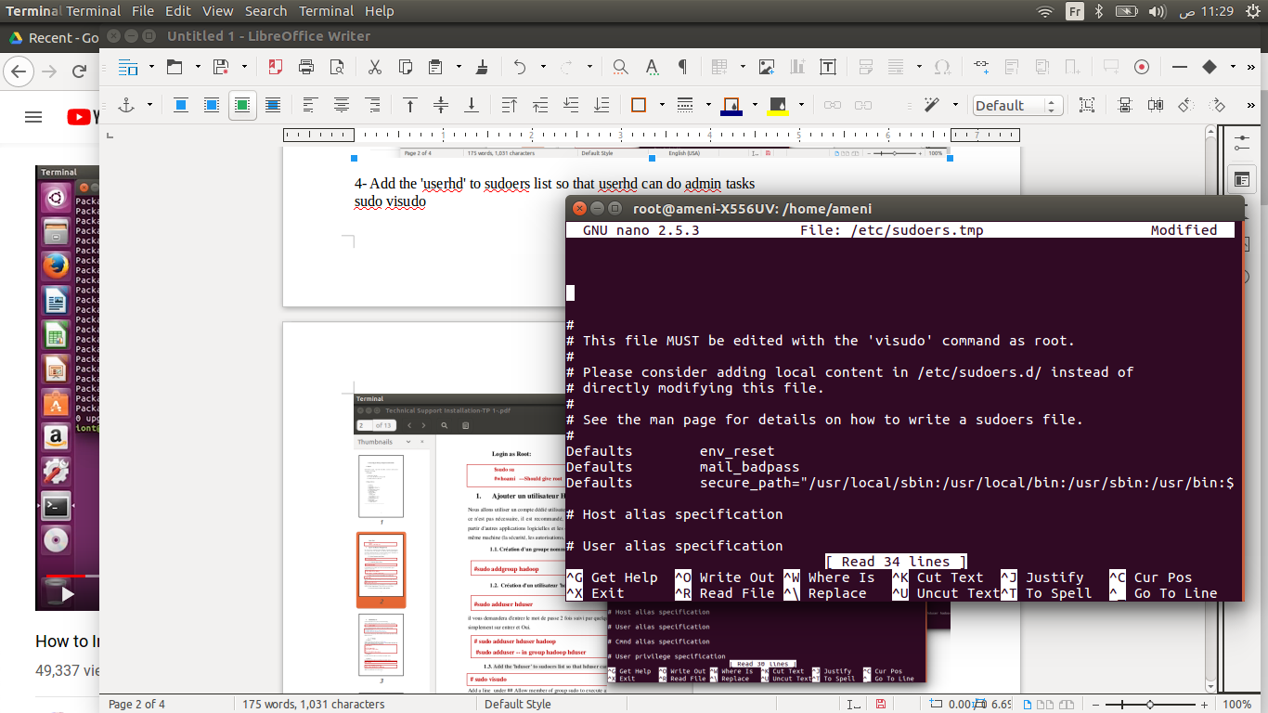

* Add a line under ## to allow member of group sudo to execute any command anywhere in the format :

userhd ALL=(ALL) ALL

* This will add the **hduser** and the **myhadoop** group on your local machine. (Click on **Ctrl-X** then **Y** for saving). Click on **Enter** to exit the editor

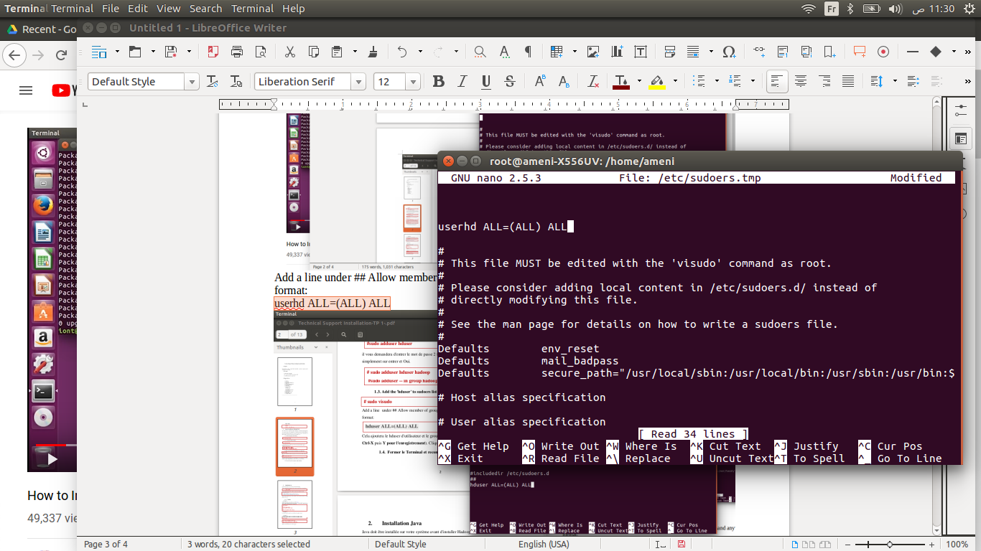

5- Close the Terminal and reconnect as a **userhd**

sudo su userhd

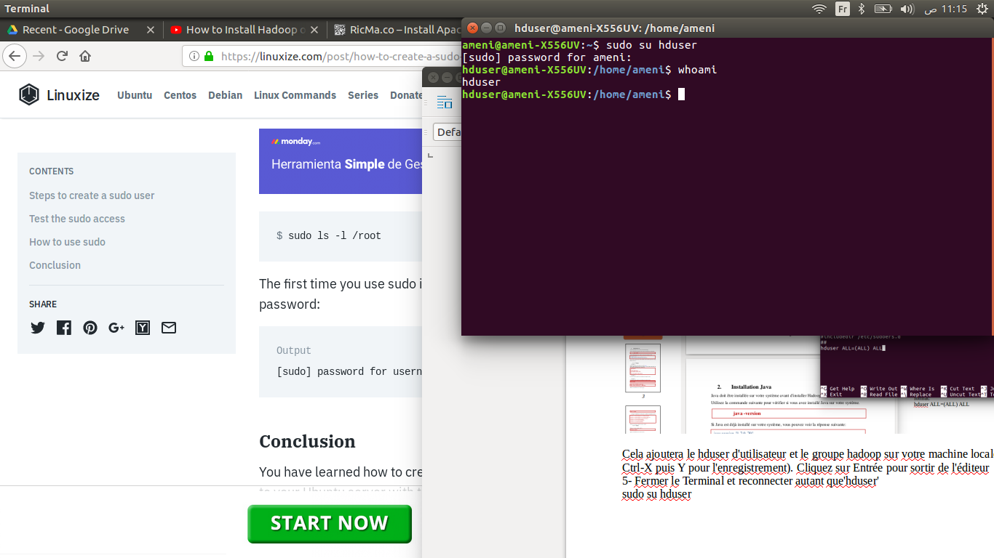

**Step 2 : Install Java**

Java must be installed on your system before installing Hadoop.

1- Check if Java is already installed

java -version

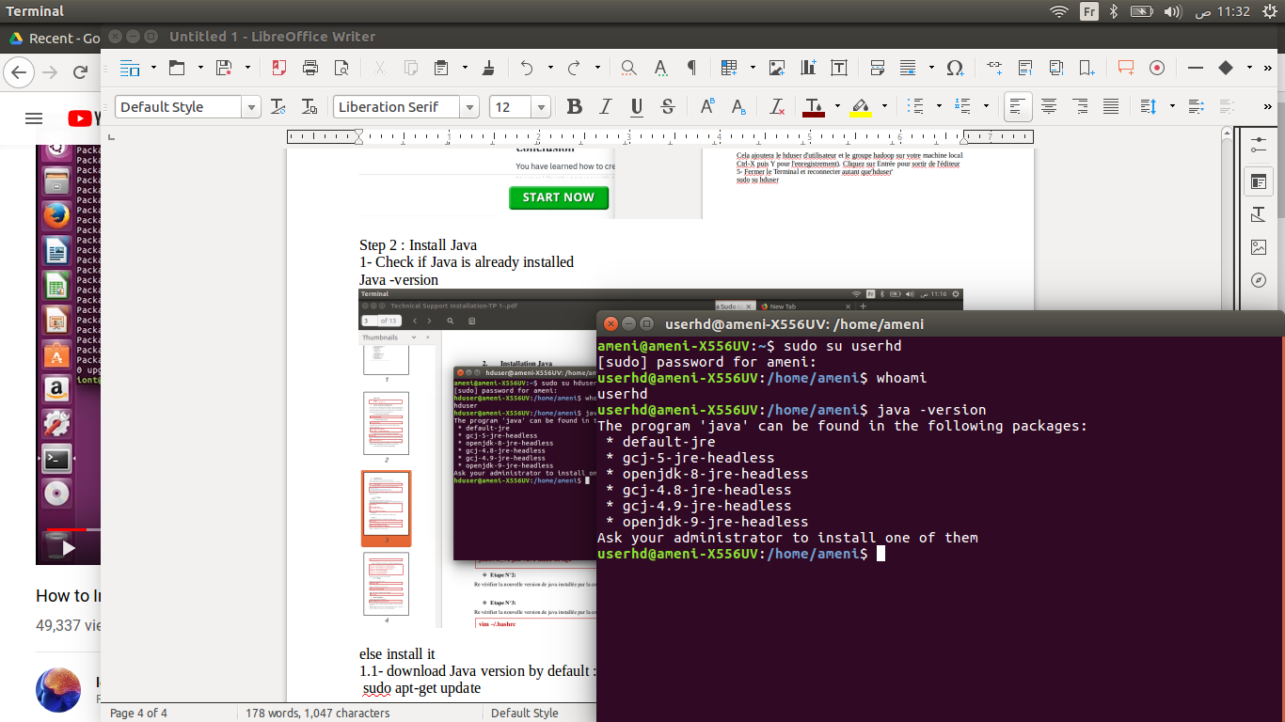

else install it

1. Download Java version by default :

* Update repositories

sudo apt-get update

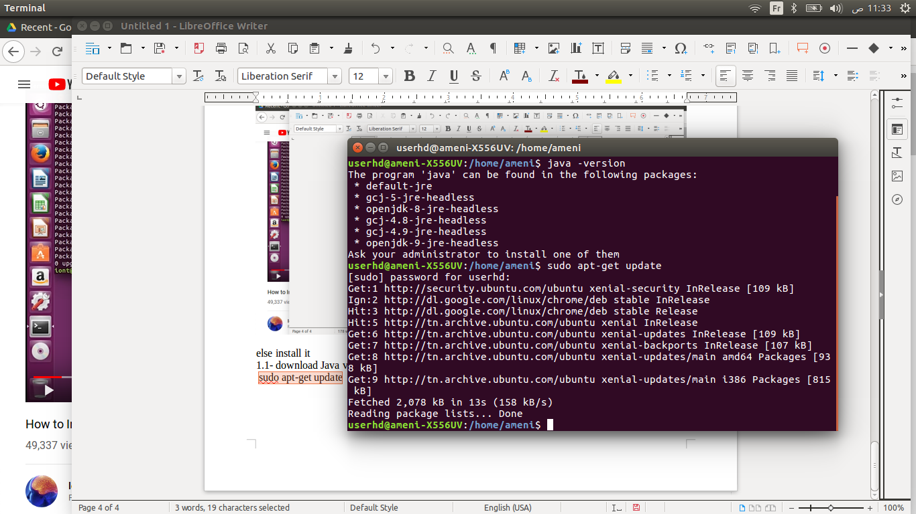

1. Apply these modifications to the current system:

sudo apt-get install default-jdk

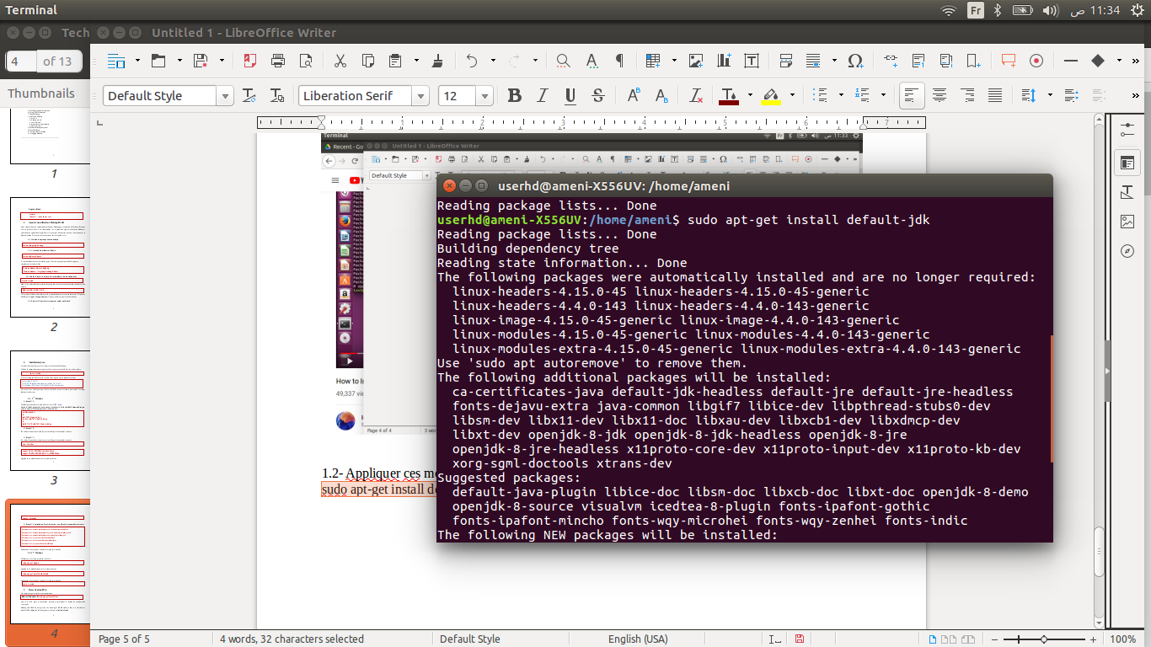

1. Check now Java version

java -version

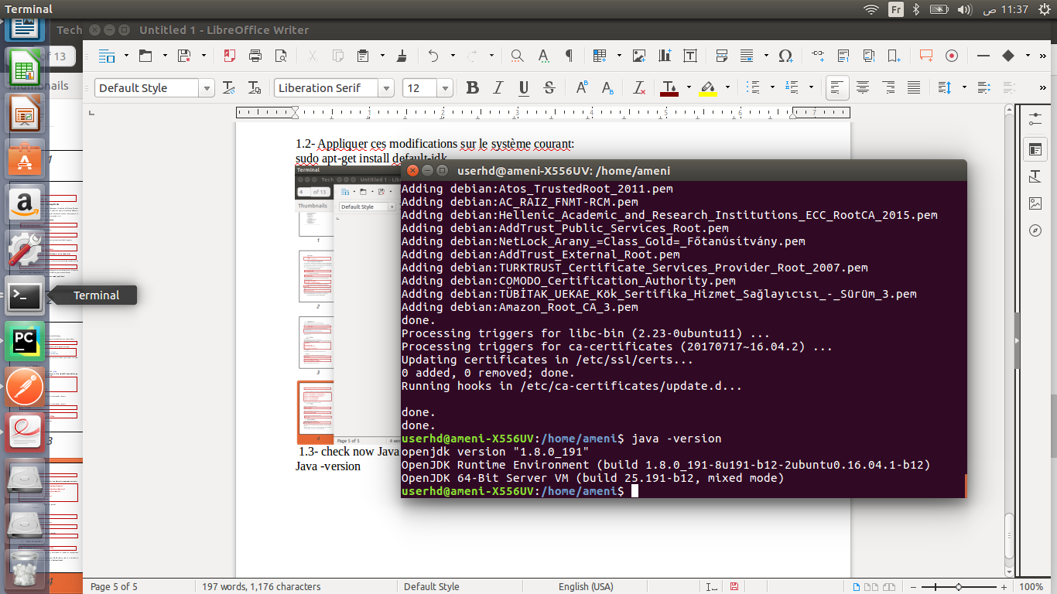

**Step 3: Disable IPv6**

Apache Hadoop supports only IPv4, so let's disable IPv6 in the kernel parameters.

1- Install command vim

sudo apt-get install vim

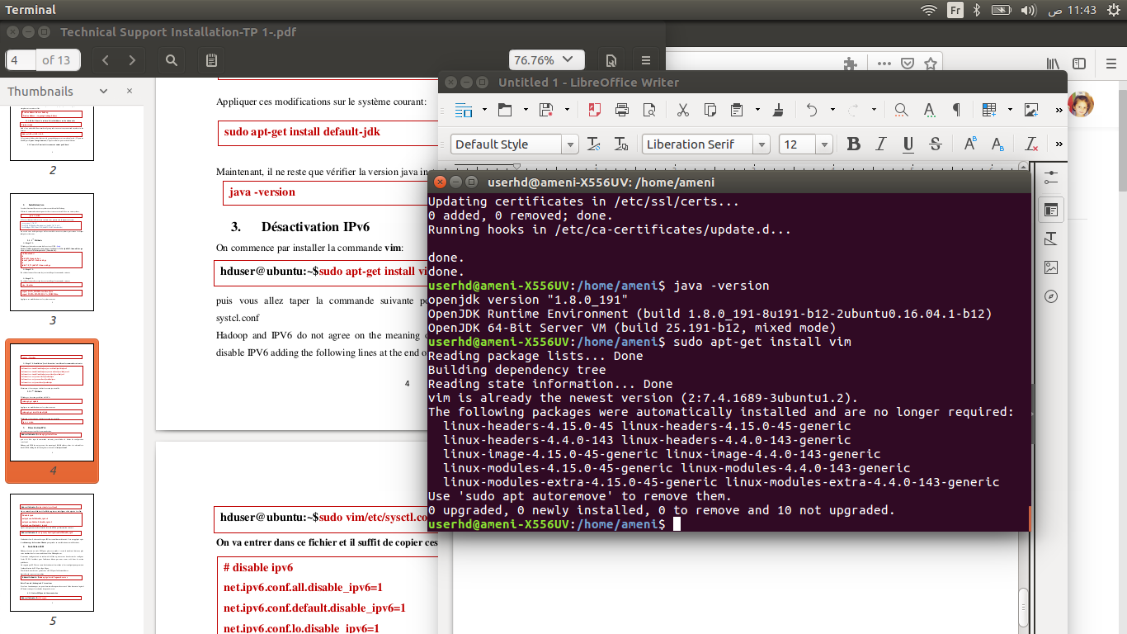

* Then you will execute the following command to display the **systcl.conf** configuration file:

sudo vim /etc/sysctl.conf

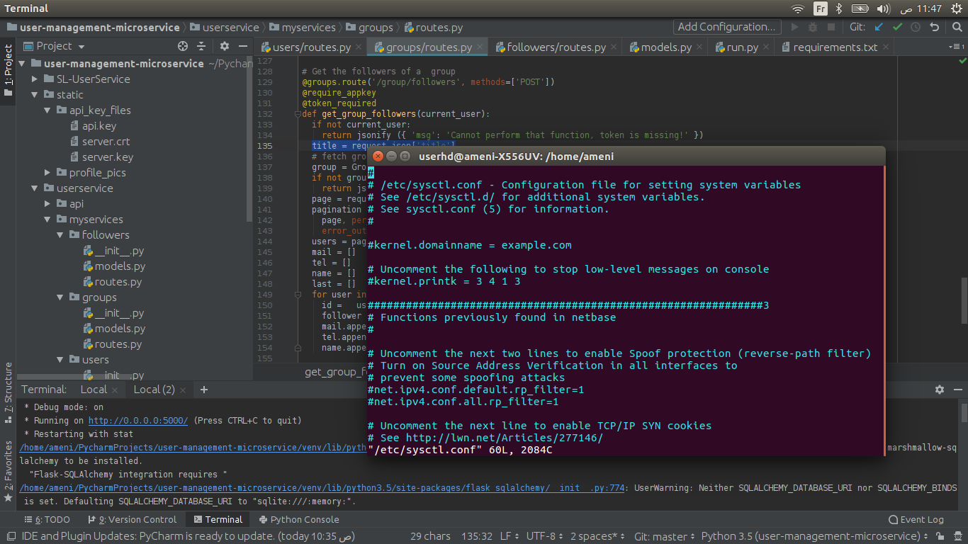

2- Hadoop and IPV6 do not agree on the meaning of 0.0.0.0 address, thus it is advisable to

disable IPV6 adding the following lines at the end of **/etc/sysctl.conf**

#disable ipv6

net.ipv6.conf.all.disable_ipv6=1

net.ipv6.conf.default.disable_ipv6=1

net.ipv6.conf.lo.disable_ipv6=1

* Then type **:wq** to save and quit

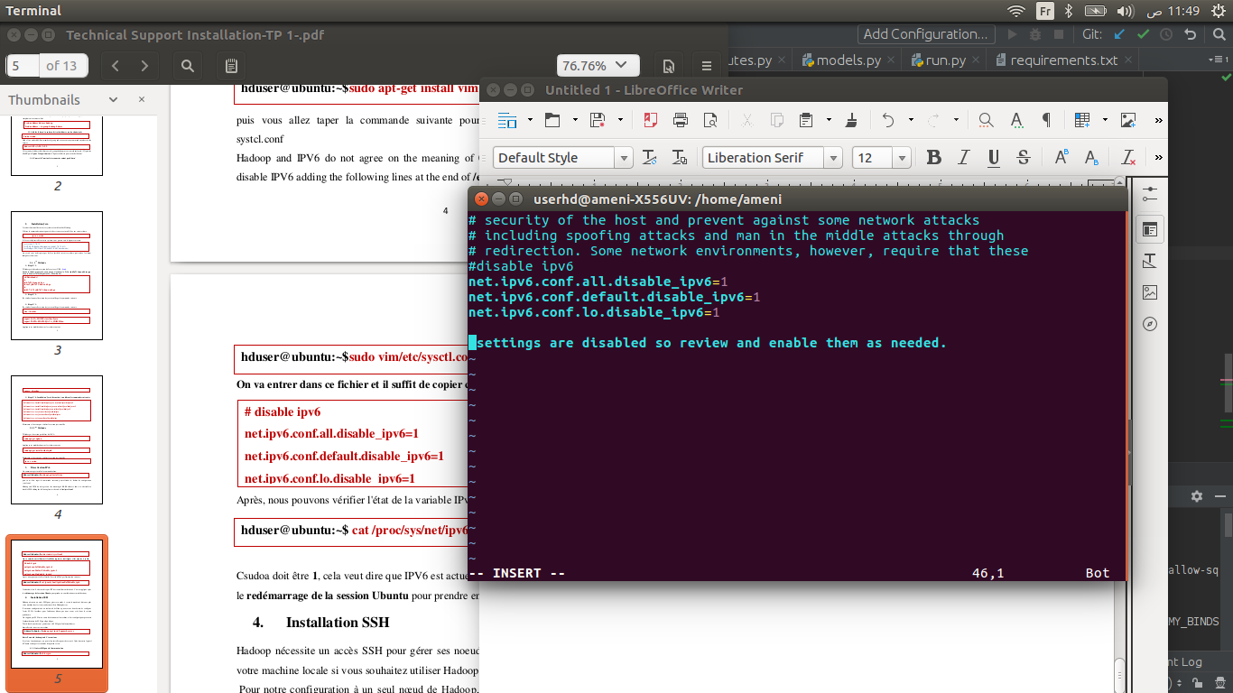

3- Reboot the system :

sudo reboot

4- Then we can check the state of the IPv6 variable via the following instruction:

cat /proc/sys/net/ipv6/conf/all/disable_ipv6

Output must be **1**, this means that IPV6 is currently disabled

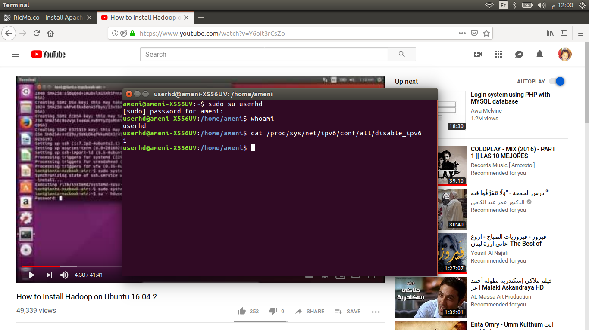

**Step 4: Configure SSH keys**

* Hadoop requires SSH access to manage its nodes, i. e. the distant machine, and your local machine if you want to use Hadoop on it. For our standalone node configuration of Hadoop, we need to configure SSH access to localhost for the user **userhd** we created in the previous section.
* It is assumed that SSH is running on the machine and is configured to allow SSH authentication by public key.
* First, we need to generate an SSH key for the user **userhd** since Hadoop needs to login without the passwords.

1. Install ssh :

sudo apt-get install openssh-server

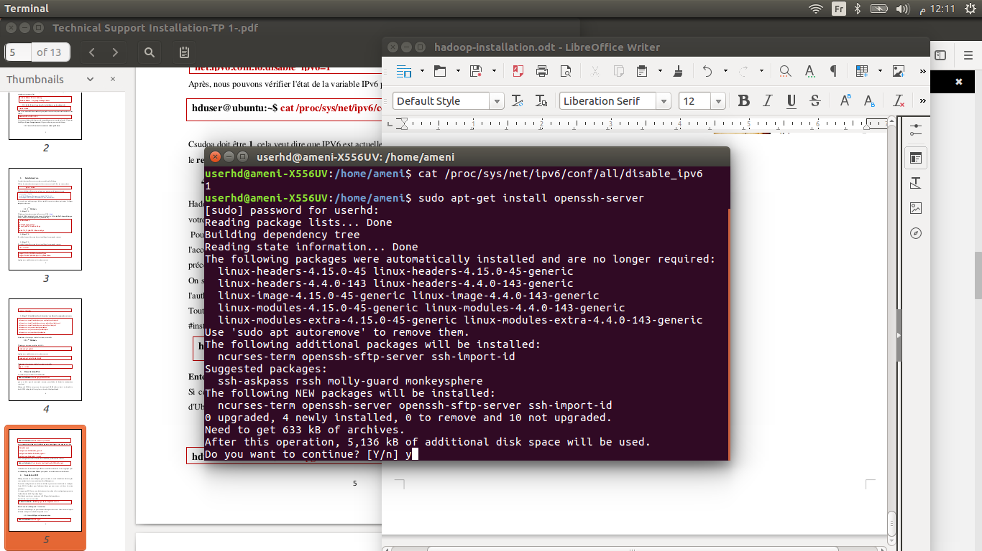

2- Generate SSH for Communication :

ssh-keygen

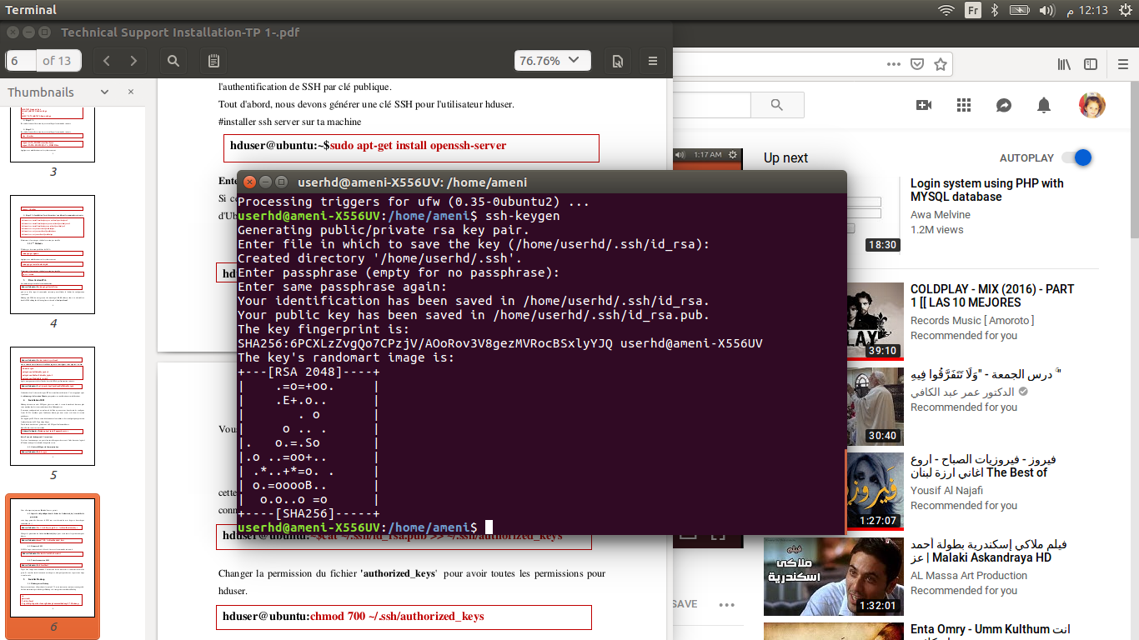then type **Enter**

3- Copy the public key into the **"authorized_key**" file and modify the permission (this step allows you to start the SSH without requiring the password in each login).

cat ~/.ssh/id_rsa.pub >> ~/.ssh/authorized_keys

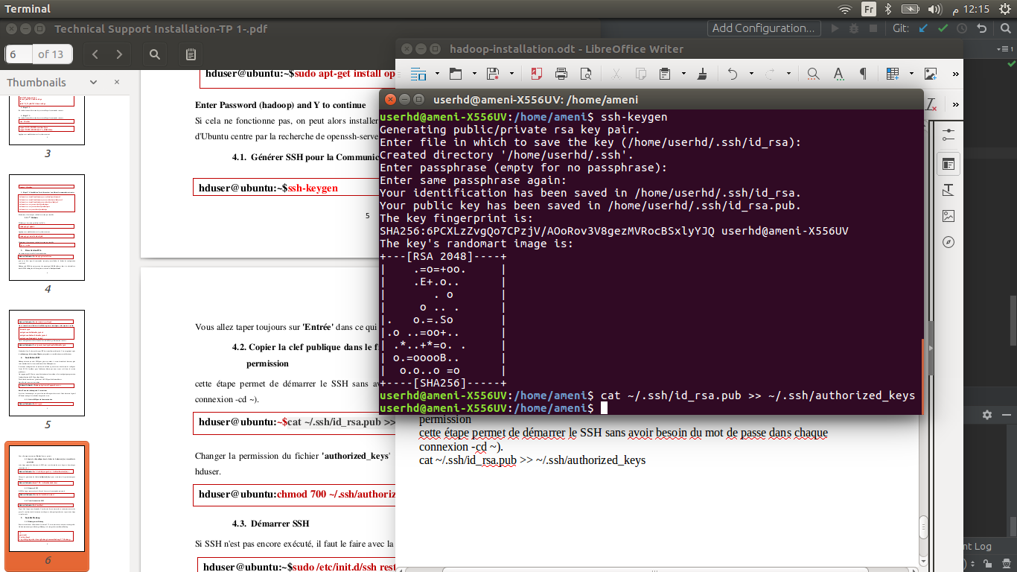

4- Edit the permission of the file **"authorized_keys"** to get all the permissions for **userhd** :

chmod 700 ~/.ssh/authorized_keys

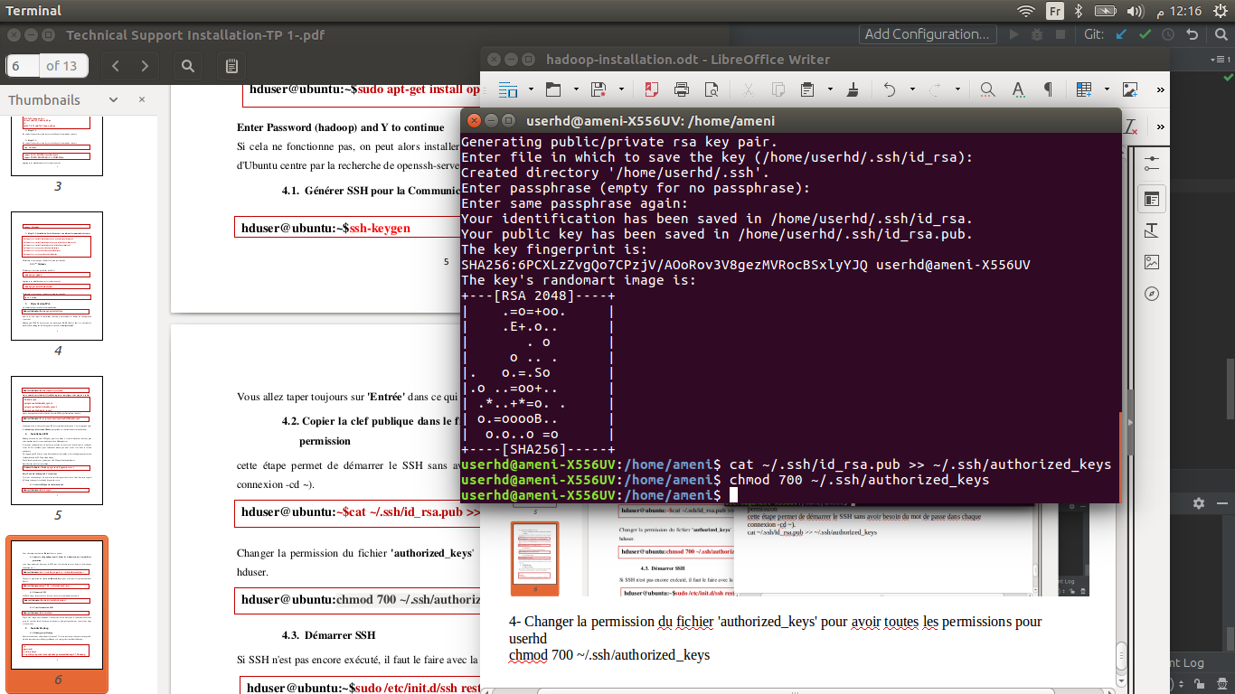

5- Start ssh :

sudo /etc/init.d/ssh restart

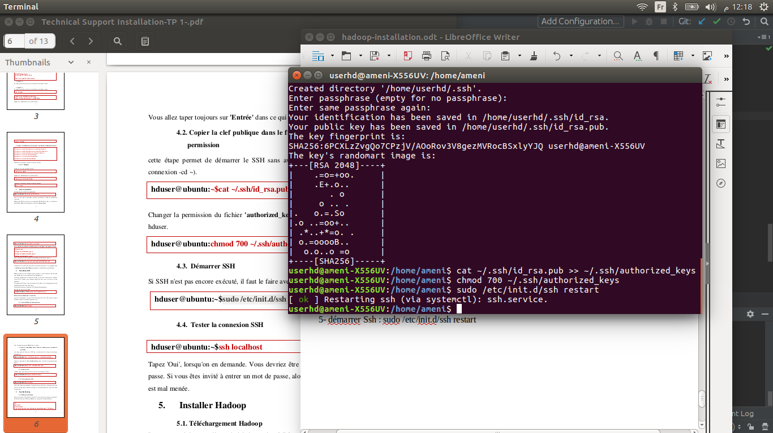

6- Test the ssh connection :

ssh localhost

* When requested, type **Yes**. You should be able to log in without a password. If you are prompted to enter a password, then something is wrong, and a step is not done properly.

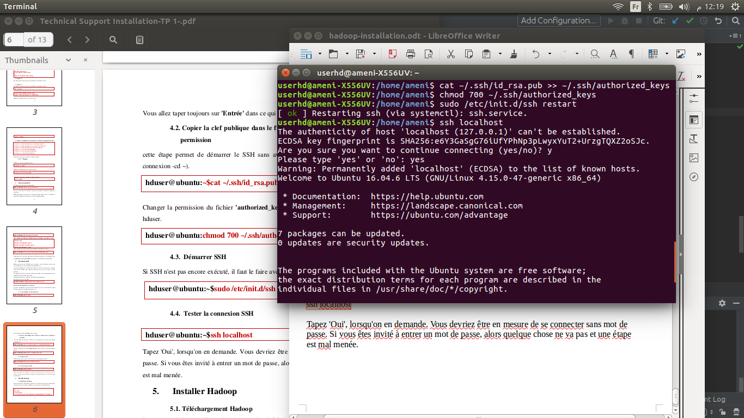

7- Now exit :

exit

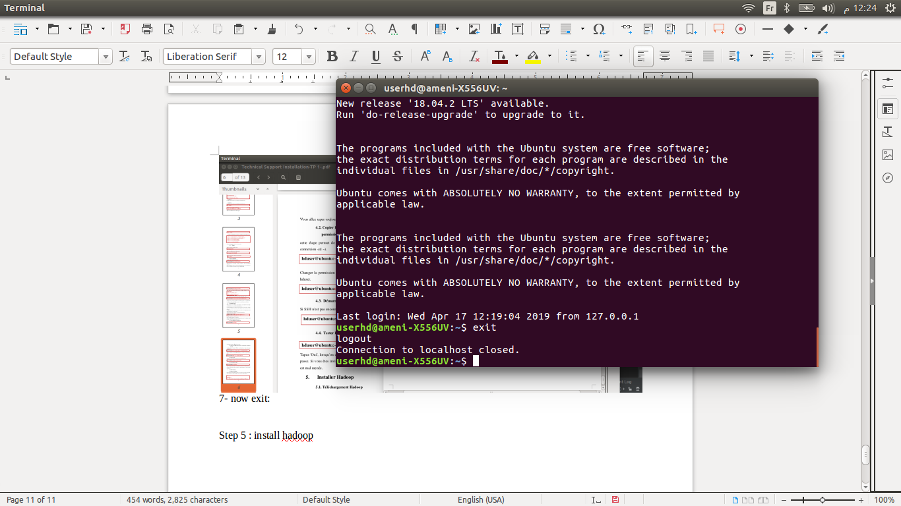

**Step 5 : Install Hadoop**

1- We are ready to install Hadoop. Unfortunately, it does not come prepackaged, but we must extract and move it to **/usr/local**

* Hadoop version 2.8.5

wget <https://www-eu.apache.org/dist/hadoop/common/hadoop-2.8.5/hadoop-2.8.5.tar.gz>

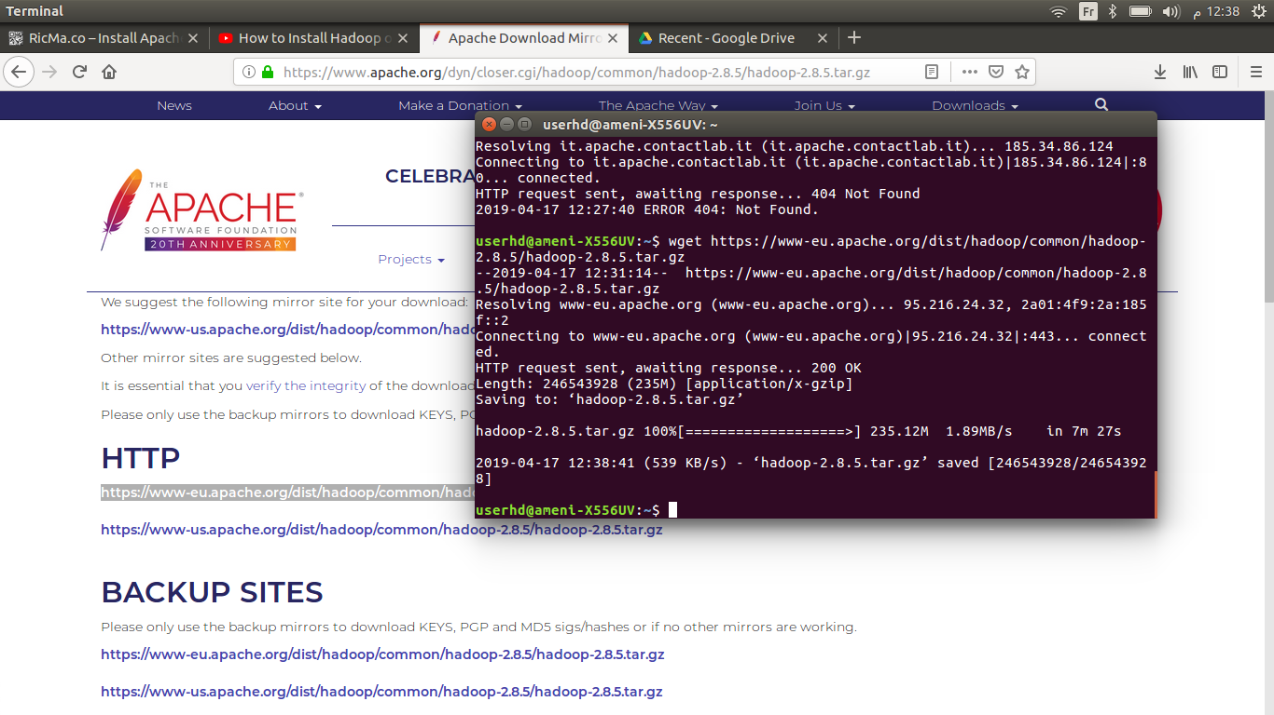(go to <https://www.apache.org/dyn/closer.cgi/hadoop/common/hadoop-2.8.5/hadoop-2.8.5.tar.gz> and copy the mirror link)

2- Extract :

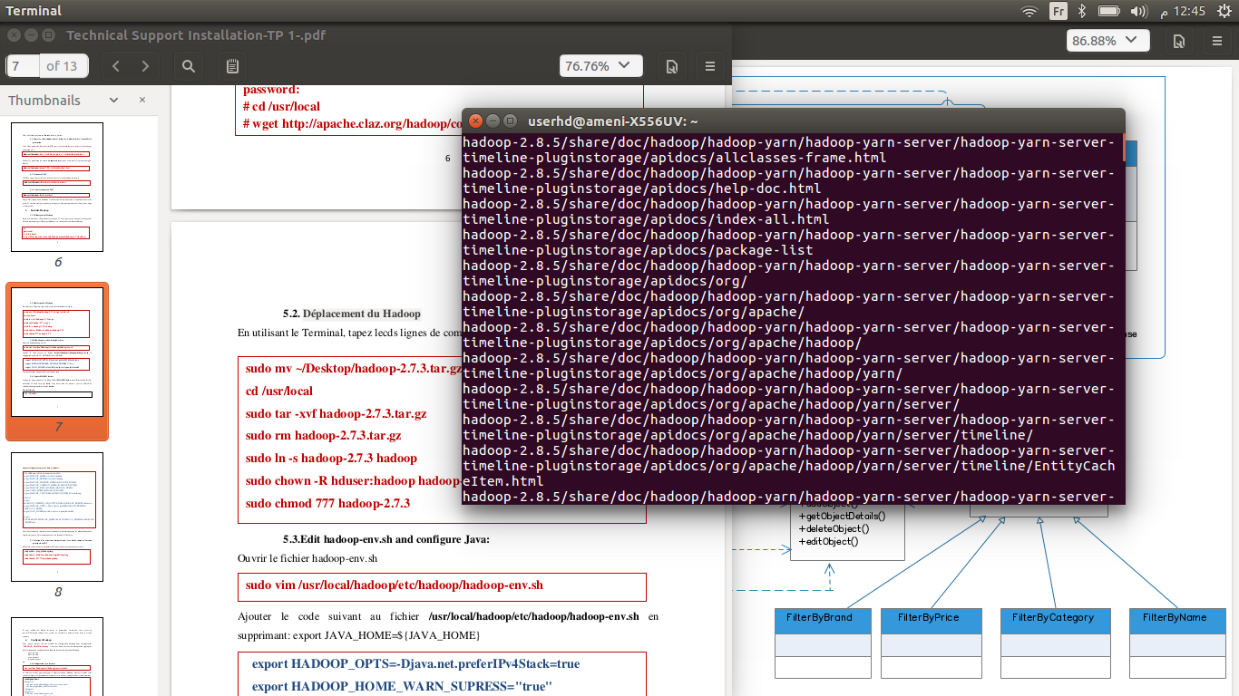tar xvf hadoop-2.8.5.tar.gz

3- Type in :

rm -rf hadoop-2.8.5.tar.gz

sudo mv hadoop-2.8.5 /usr/local

sudo ln -sf /usr/local/hadoop-2.8.5/ /usr/local/hadoop

sudo chown -R userhd:myhadoop /usr/local/hadoop-2.8.5/

sudo chmod 777 hadoop-2.8.5

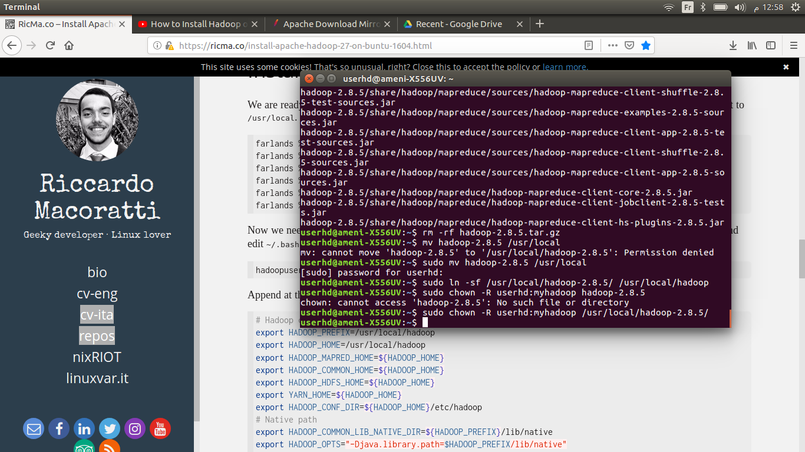

4- Edit **hadoop-env.sh** and configure Java:

* Open the **hadoop-env.sh** file :

sudo vim /usr/local/hadoop/etc/hadoop/hadoop-env.sh

* Add the following code to the file **/usr/local/hadoop/etc/hadoop/hadoop-env.sh** and remove **export JAVA_HOME=${JAVA_HOME} :**

export HADOOP_OPTS=-Djava.net.preferIPv4Stack=true

export HADOOP_HOME_WARN_SUPRESS="true"

export JAVA_HOME==/usr/lib/jvm/java-8-openjdk-amd64

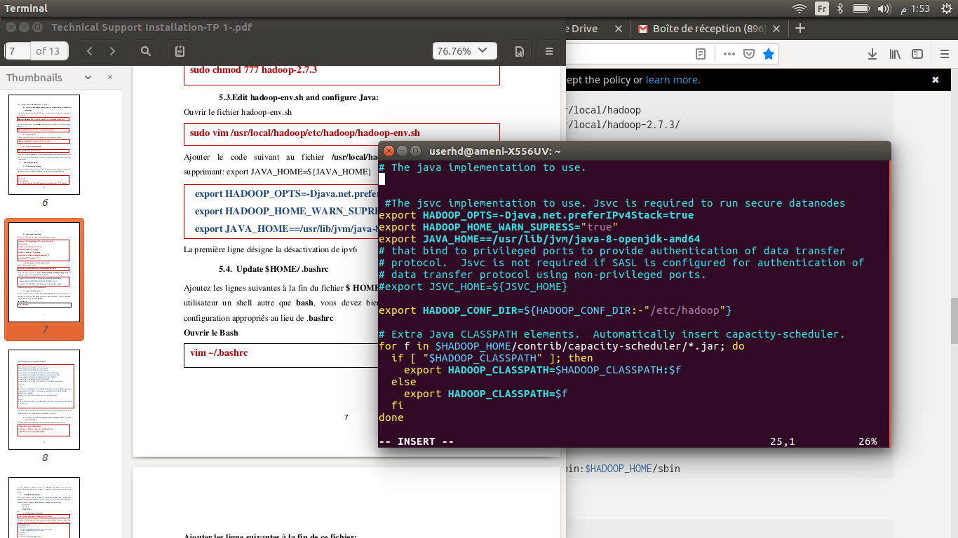

5- Configure some environmental variables :

* Open bash file (via the command **vim** or **nano**)

vim ~/.bashrc

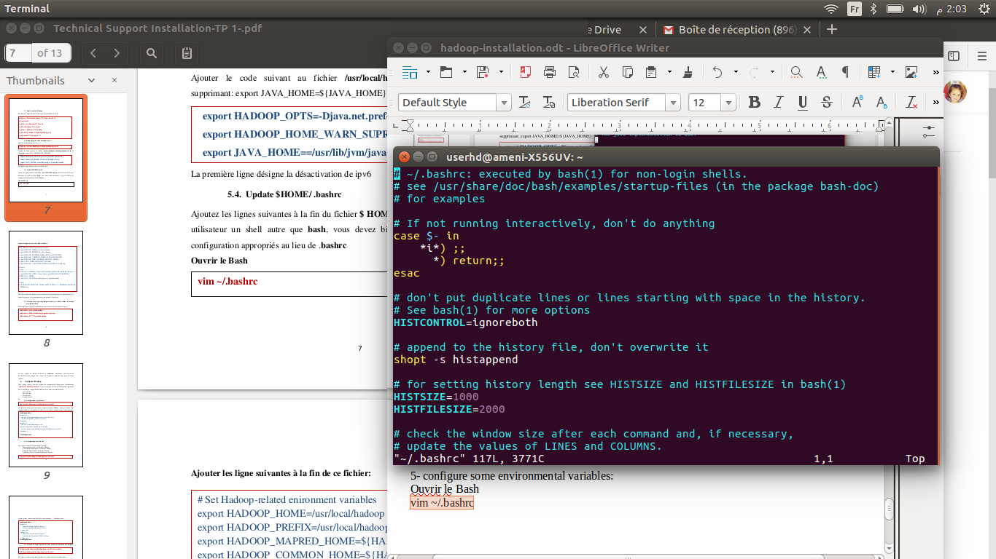

* Append at the end :

# Hadoop config

export HADOOP_PREFIX=/usr/local/hadoop

export HADOOP_HOME=/usr/local/hadoop

export HADOOP_MAPRED_HOME=${HADOOP_HOME}

export HADOOP_COMMON_HOME=${HADOOP_HOME}

export HADOOP_HDFS_HOME=${HADOOP_HOME}

export YARN_HOME=${HADOOP_HOME}

export HADOOP_CONF_DIR=${HADOOP_HOME}/etc/hadoop

# Native path

export HADOOP_COMMON_LIB_NATIVE_DIR=${HADOOP_PREFIX}/lib/native

export HADOOP_OPTS="-Djava.library.path=$HADOOP_PREFIX/lib/native"

# Java path

export JAVA_HOME="/usr"

# OS path

export PATH=$PATH:$HADOOP_HOME/bin:$JAVA_PATH/bin:$HADOOP_HOME/sbin

* 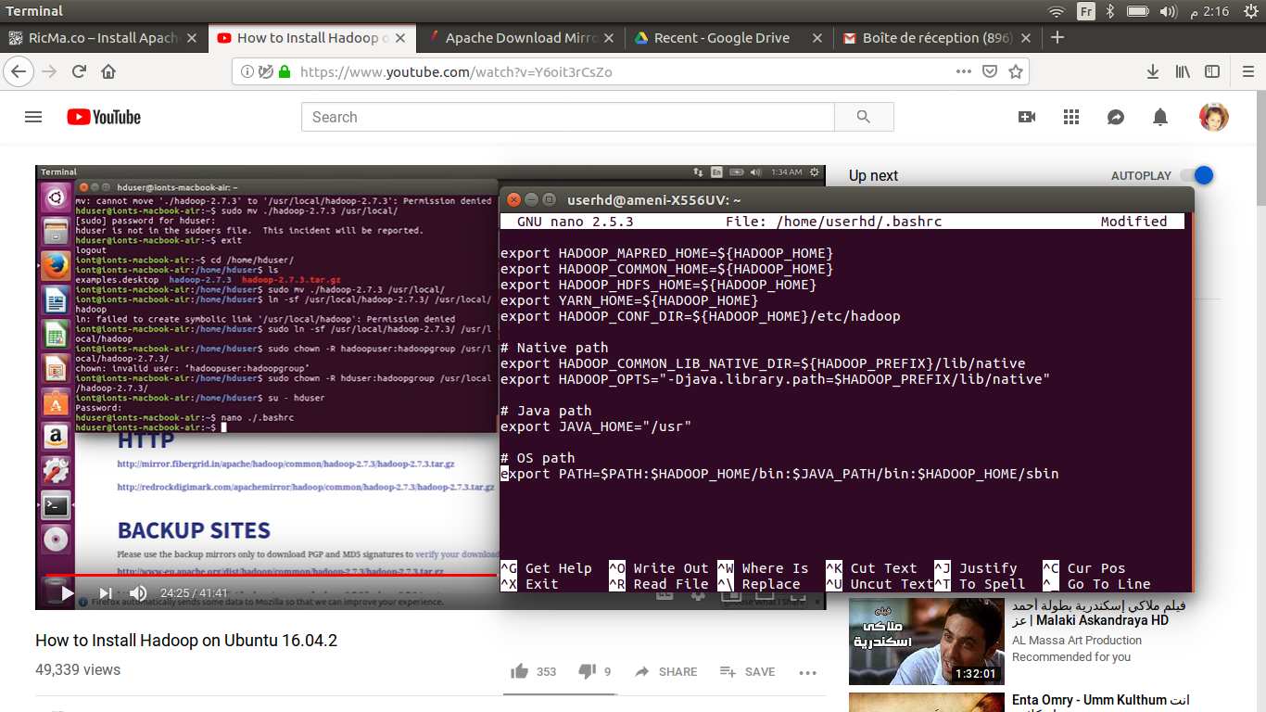Type **ctrl+x** , **y** and **Enter**
* Next, source **~/.bashrc** to apply changes :

source ~/.bashrc

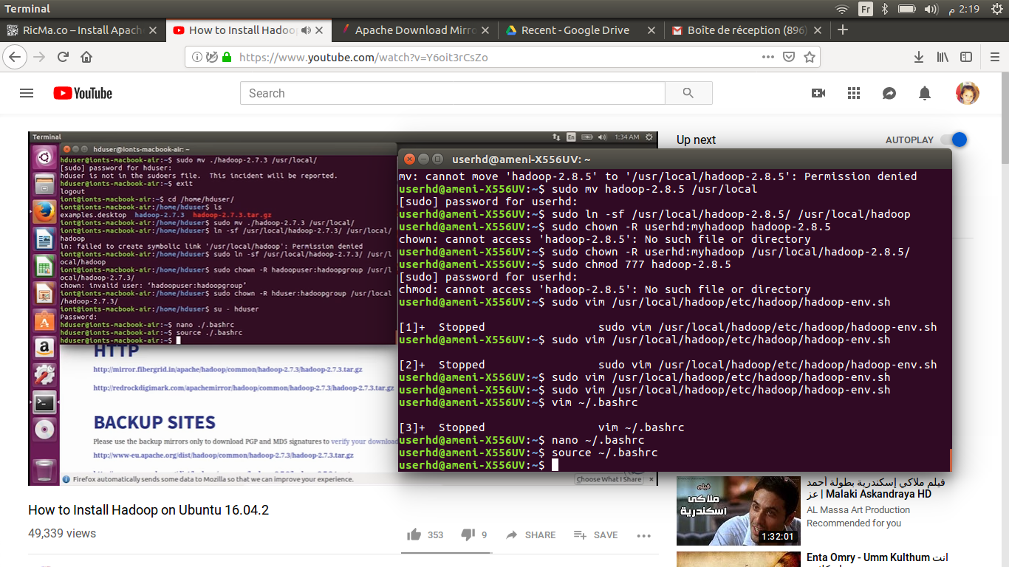

* Now we need to edit /**usr/local/hadoop/etc/hadoop/hadoop-env.sh** :

nano /usr/local/hadoop/etc/hadoop/hadoop-env.sh

* And add this at the end :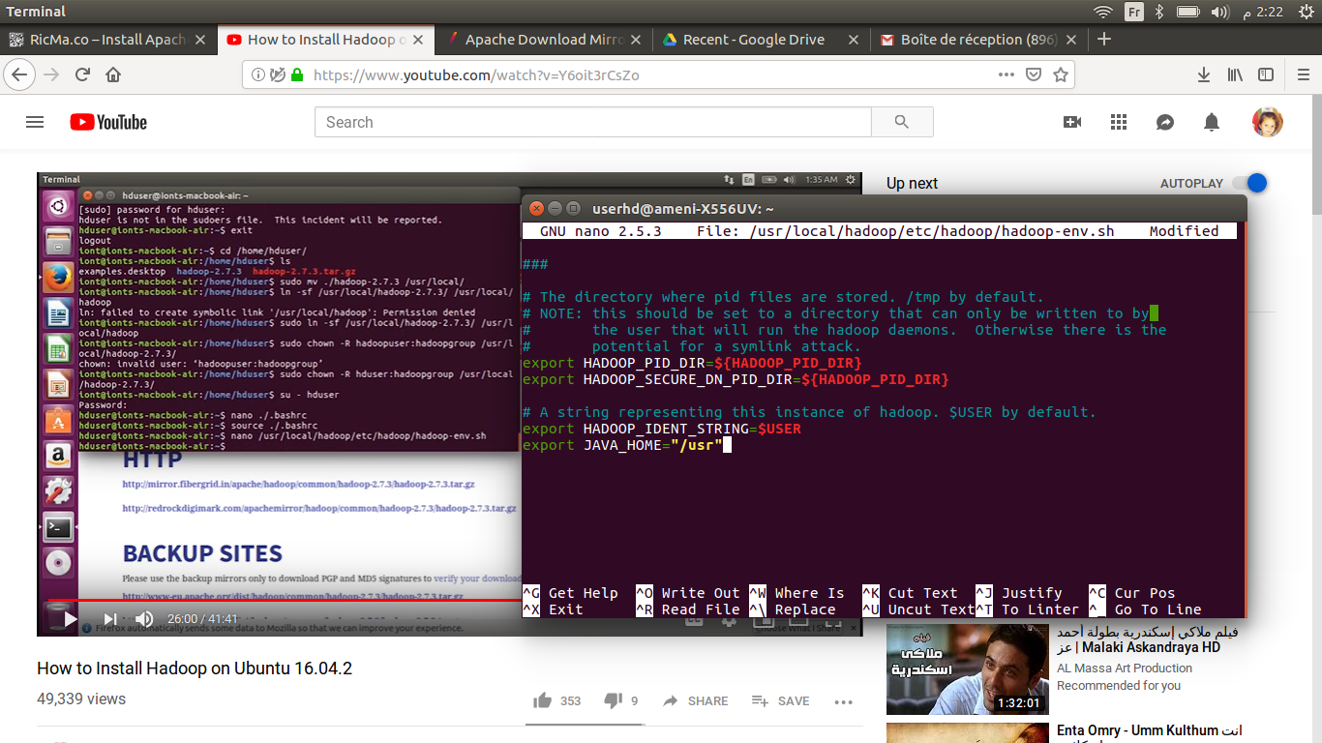 export JAVA_HOME="/usr"
* Type **ctrl+x** , **y** and **Enter**

6- Create a temporary directory that will be used as the **DFS**. Now, we will create the directory and define the necessary privileges and permissions :

sudo mkdir -p /app/hadoop/tmp

sudo chown -R userhd:myhadoop /app/hadoop/tmp

sudo chmod -R 777 /app/hadoop/tmp

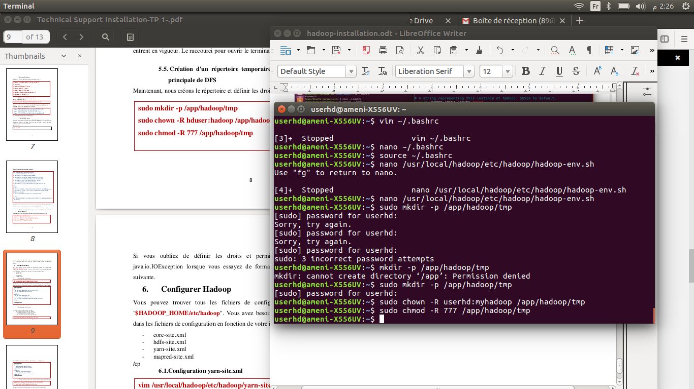

**Step 6 : Hadoop Configuration**

* Hadoop configuration is quite hard, because it has a lot of config files. We need to navigate to **/usr/local/hadoop/etc/hadoop** and edit these files:
* core-site.xml
* hdfs-site.xml
* mapred-site.xml (needs to be copied from mapred-site.xml.template)
* yarn-site.xml
* They all are XML files with a top-level **<configuration>** node. For clarity we report the configuration node only.

1. Navigate to **/usr/local/hadoop/etc/Hadoop :**

cd /usr/local/hadoop/etc/hadoop

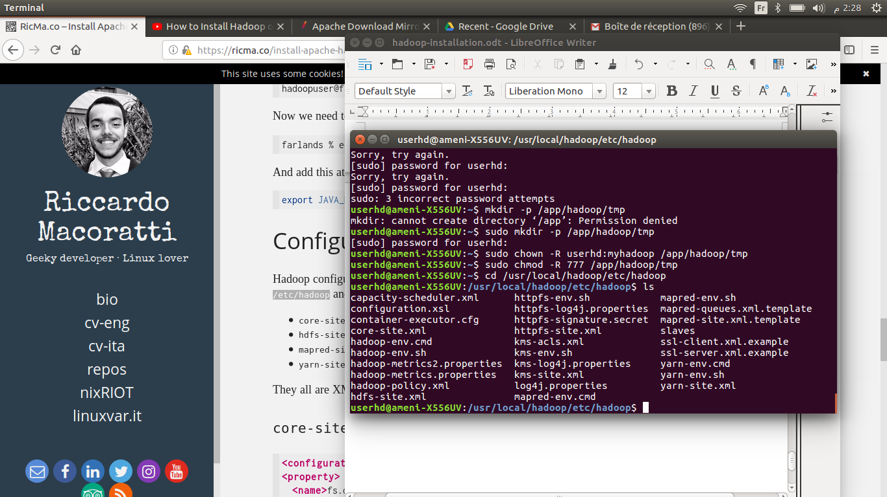

2- edit **core-site.xml** :

nano core-site.xml

* Add this :

<configuration>

<property>

<name>fs.default.name</name>

<value>hdfs://localhost:9000</value>

</property>

</configuration>

* 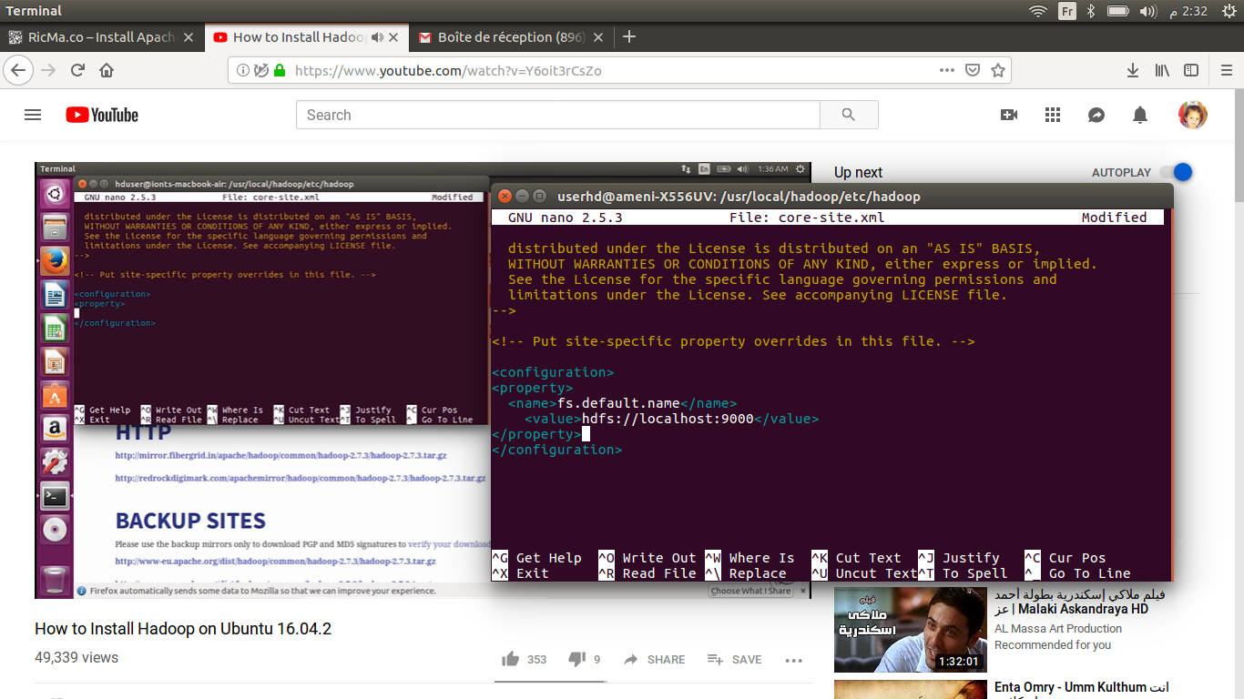Then type : **ctrl+x**, **y** and **Enter**

3- Edit **hdfs-site.xml** :

nano hdfs-site.xml

* Add this :

<configuration>

<property>

<name>dfs.replication</name>

<value>1</value>

</property>

<property>

<name>dfs.name.dir</name>

<value>file:/usr/local/hadoop/hadoopdata/hdfs/namenode</value>

</property>

<property>

<name>dfs.data.dir</name>

<value>file:/usr/local/hadoop/hadoopdata/hdfs/datanode</value>

</property>

</configuration>

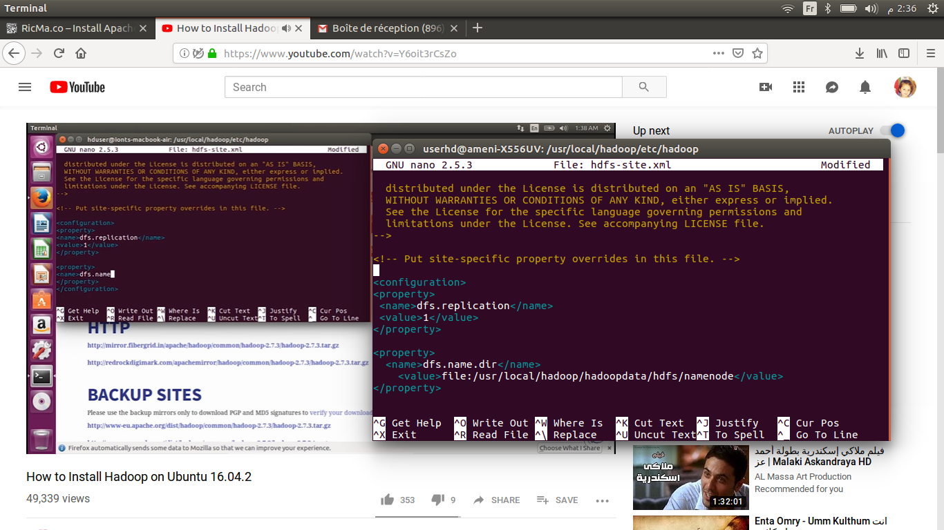

4- Edit **mapred-site.xml.template** :

nano mapred-site.xml.template

* Add :

<configuration>

<property>

<name>mapreduce.framework.name</name>

<value>yarn</value>

</property>

</configuration>

* Type : **ctrl+ x** and **y**, change file name to : **mapred-site.xml** and save it

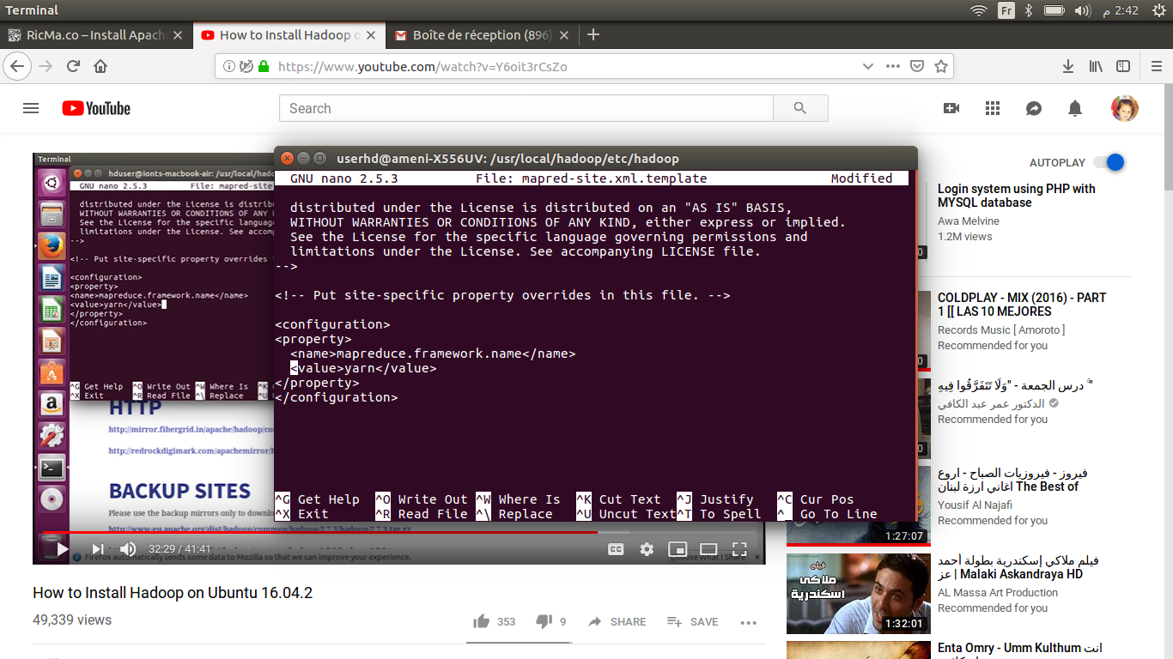

5- Edit **yarn-site.xml** :

nano yarn-site.xml

* Add :

<configuration>

<property>

<name>yarn.nodemanager.aux-services</name>

<value>mapreduce_shuffle</value>

</property>

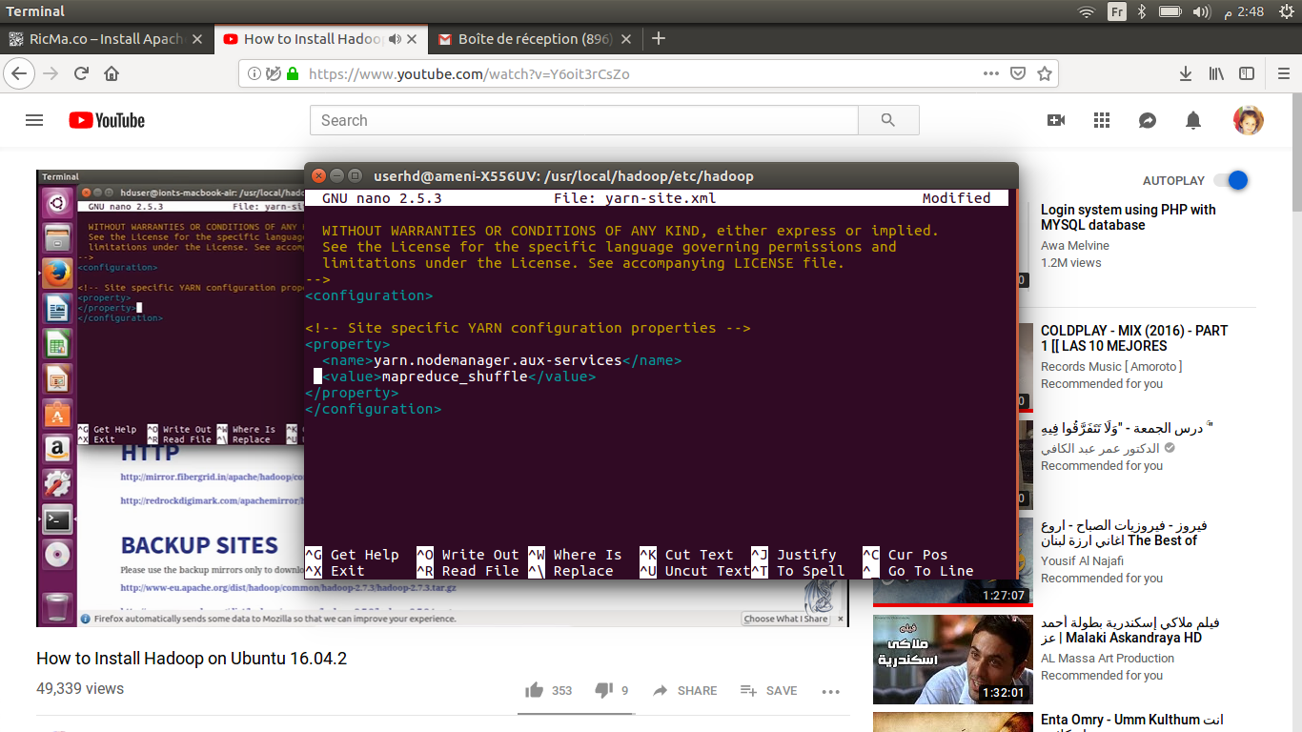</configuration>

6- Next, we need to format the **namenode** filesystem with the following command :

hdf namenode -format

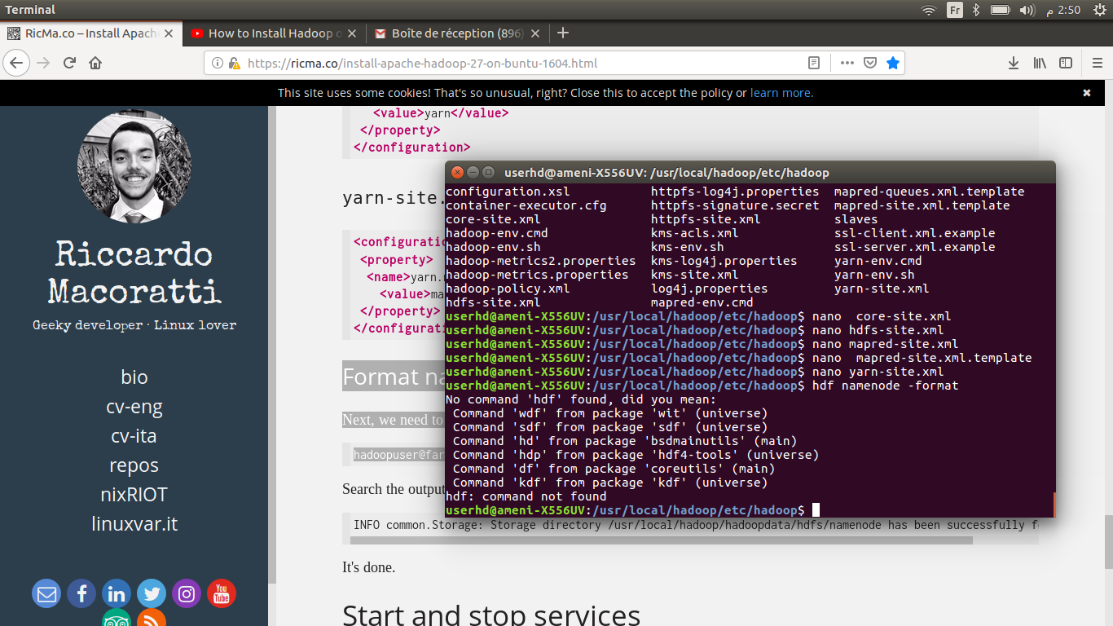 **In case of error : command not found

try this command : hdfs namenode -format

* Search the output : if you can read a string like this :

INFO common.Storage: Storage directory /usr/local/hadoop/hadoopdata/hdfs/namenode has been successfully formatted.

Then it is done !

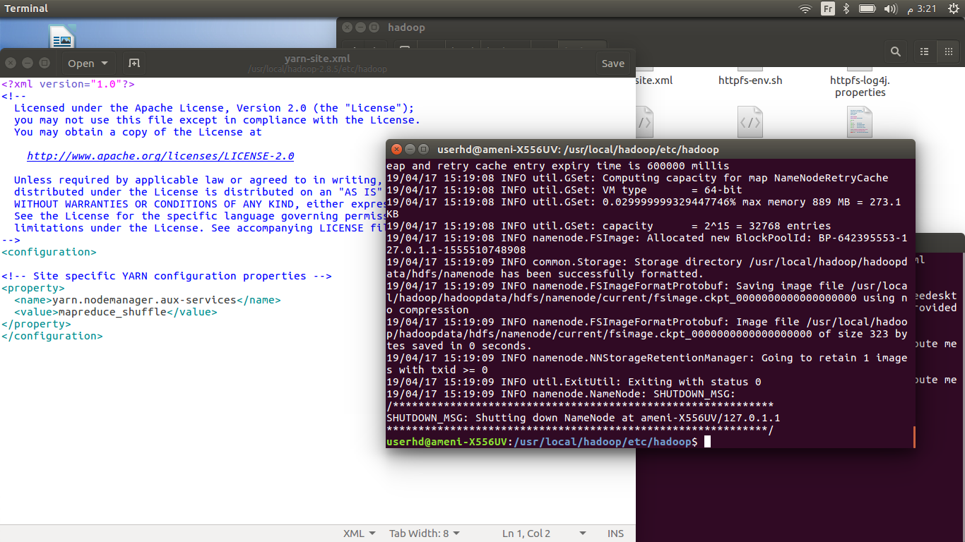

**Step 7: Start and stop services**

1- Now move back to the original folder

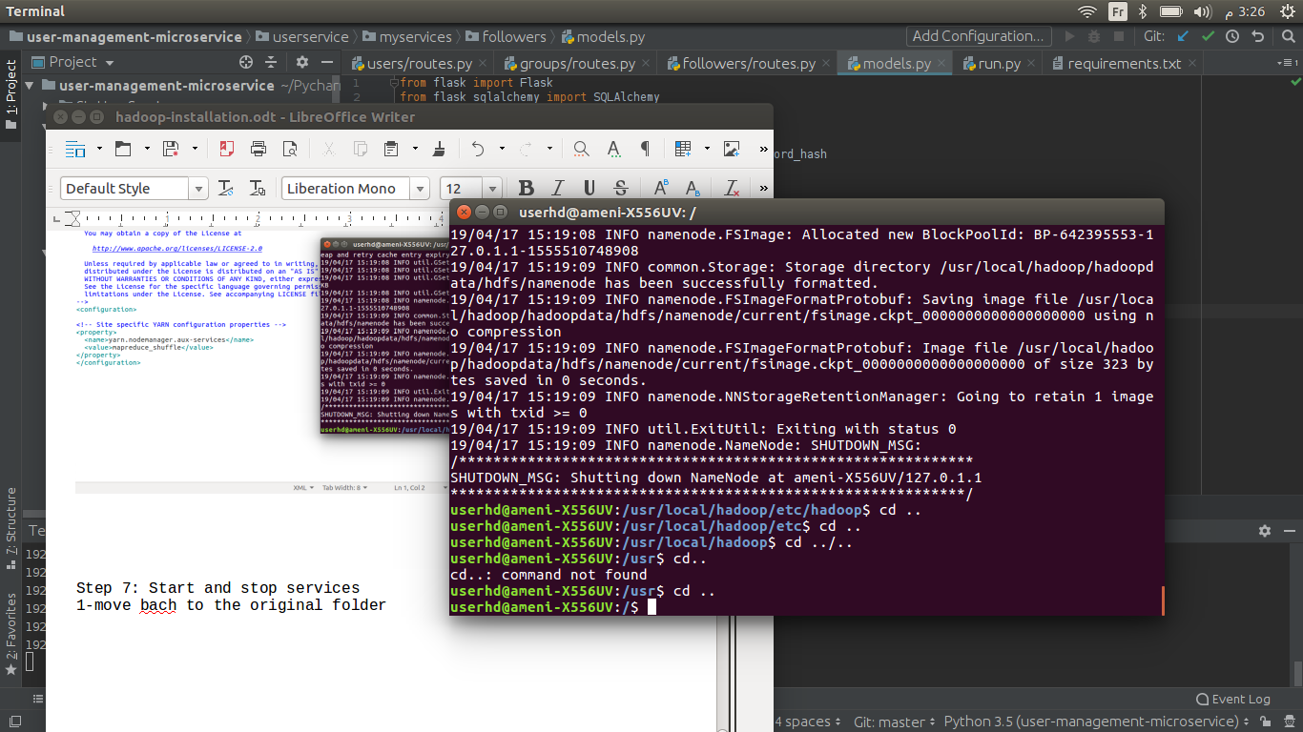

2- Then, the last thing to do is starting Hadoop services :

start-dfs.sh

* 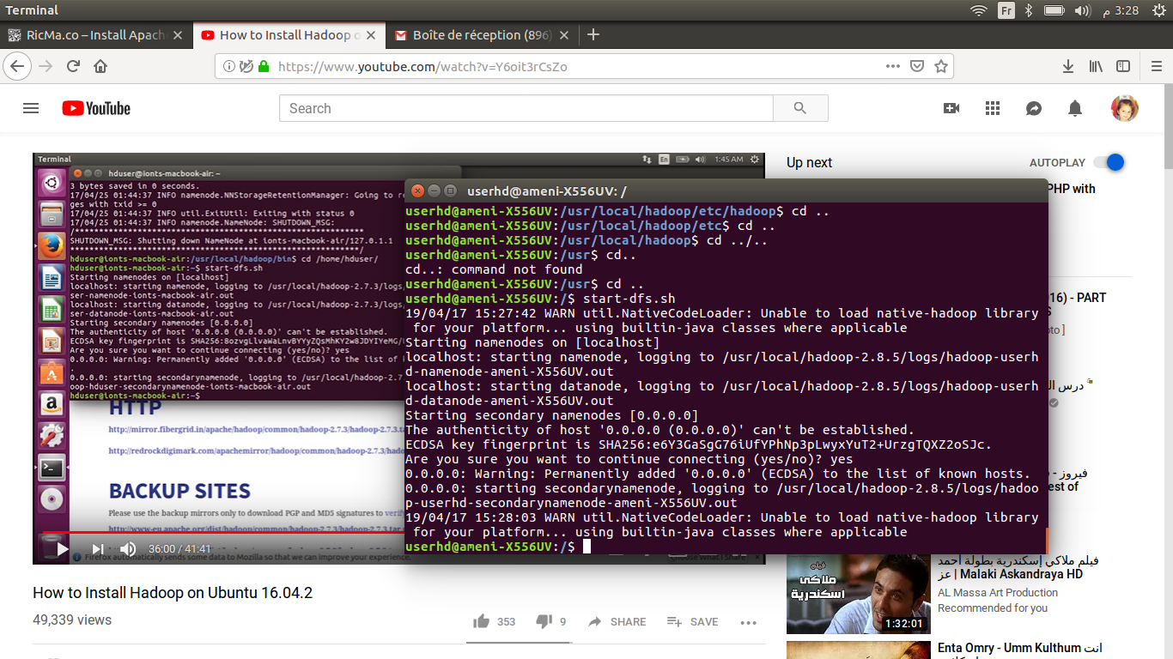When asking for, type **yes** and **Enter**
* Type in :

start-yarn.sh

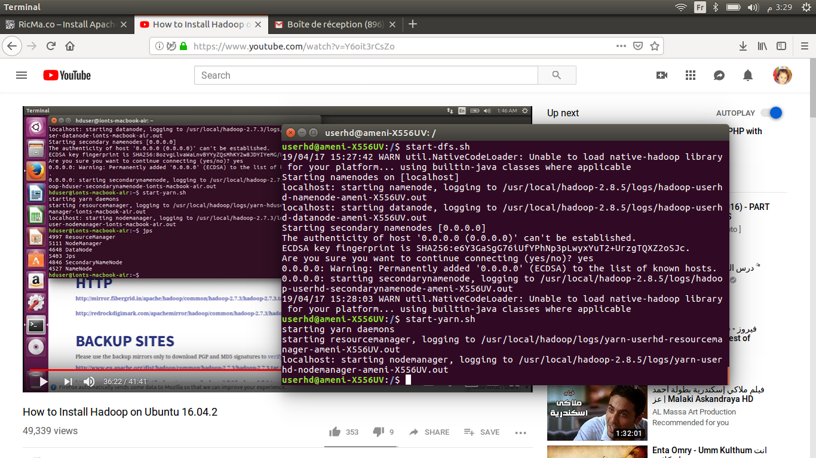

2-To check the status of the services, use this command :

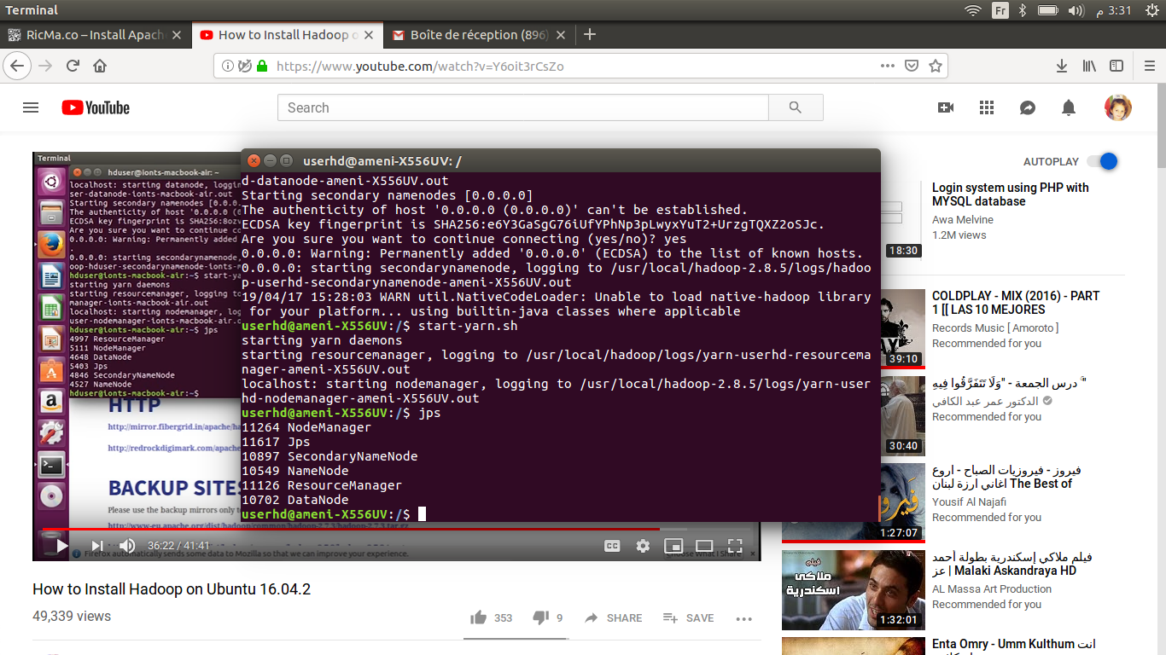jps

1. Check if Hadoop is successfully installed with the command :

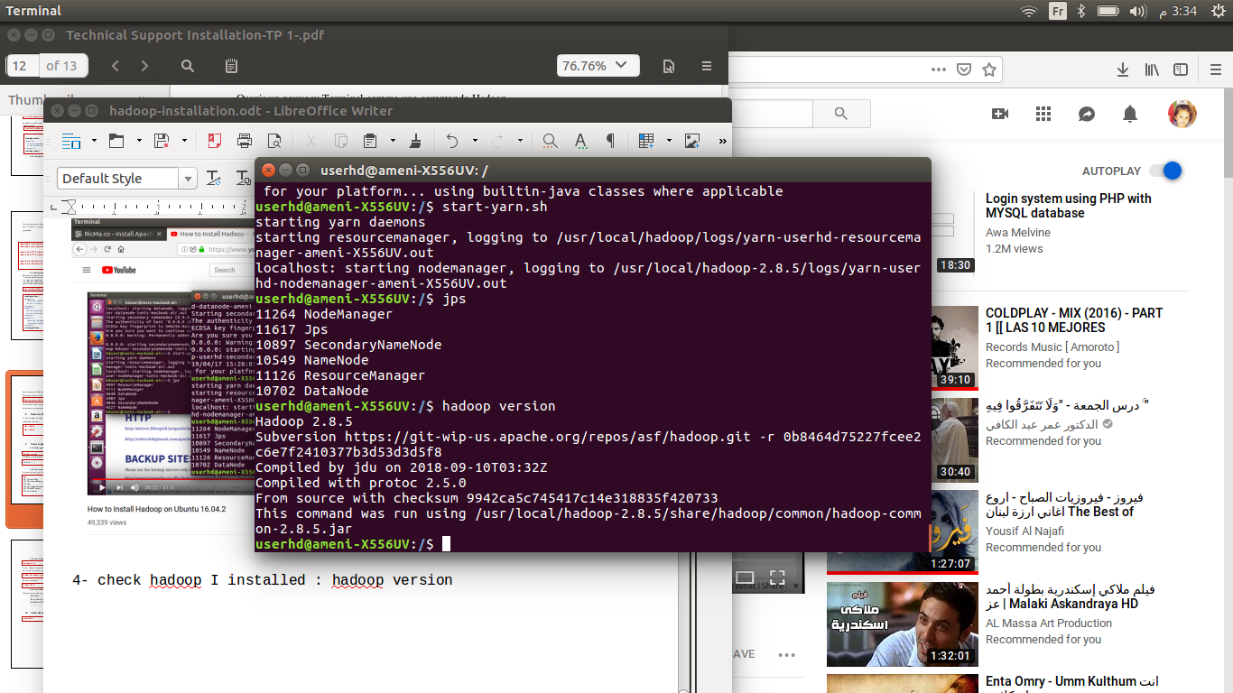 hadoop version

Congratulations, you made it !

4- To stop services, these are the commands:

stop-dfs.sh

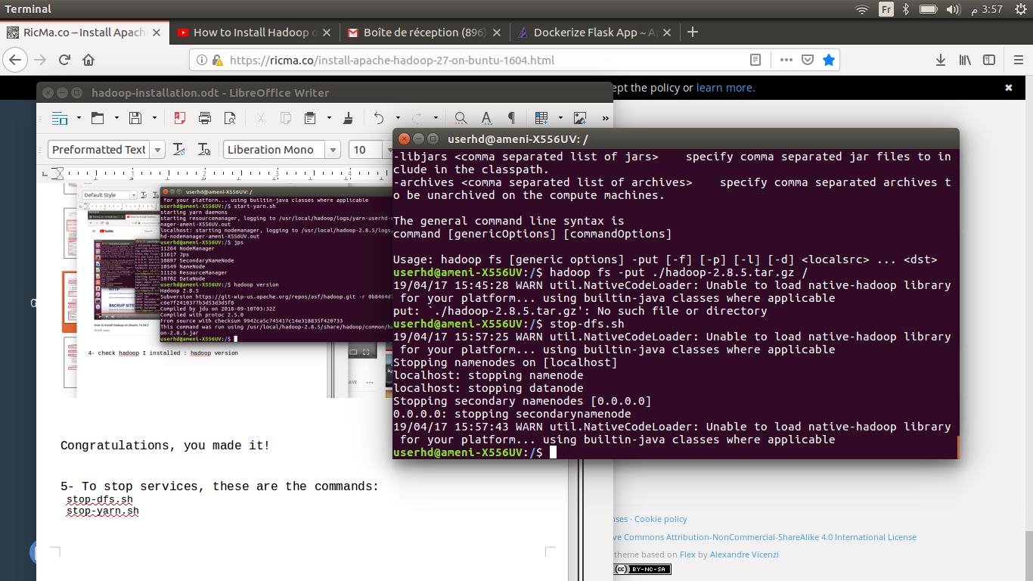

stop-yarn.sh

